Ideation Phase
Define the Problem Statements

Date | 03 February 2026
Team ID | LTVIP2026TMIDS90283
Project Name | rising waters: a machine learning approach to flood prediction

🧩 Customer Problem Statements
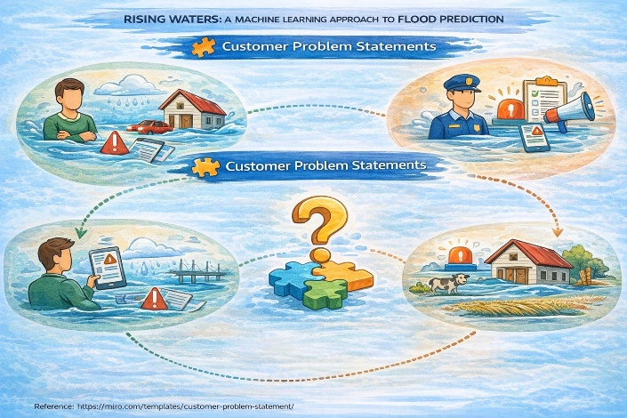
✅ PROBLEM STATEMENT–1 (Local Resident)
I am a resident living in a flood-prone area
I’m trying to know in advance whether heavy rainfall may cause flooding in my locality
But I do not receive early and accurate flood warnings
Because traditional alert systems depend on delayed manual reports and outdated data
Which makes me feel anxious, unsafe, and unprepared during heavy rain seasons
✅ PROBLEM STATEMENT–2 (Local Government / Disaster Management Officer)
I am a disaster management officer responsible for community safety
I’m trying to predict flood risks early and allocate resources effectively
But I lack a data-driven real-time predictive system
Because current methods rely mainly on historical patterns and manual monitoring
Which makes me feel concerned about delayed response and potential loss of lives and property
✅ PROBLEM STATEMENT–3 (Farmer in Flood-Prone Region)
I am a farmer depending on seasonal rainfall
I’m trying to protect my crops and livestock from unexpected floods
But I do not have access to predictive flood risk information
Because there is no accessible AI-based forecasting system available in my region
Which makes me feel financially insecure and stressed about potential crop loss

